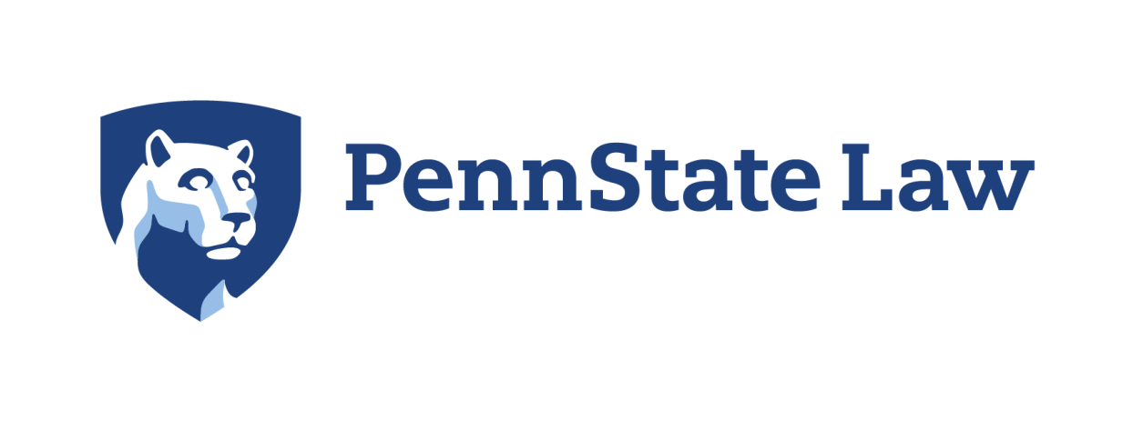
Education Law Day 2016 September 21, 2016
Penn State Law and Penn State College of Education
9:00 AM 9:20AM | Welcome and agenda items  Dr. Lawrence Wess, Exec Dir. PSSC  James W. Houck, Interim Dean Penn State Law  Dr. Gregory Kelly Assoc. Dean College of Education
9:20 AM – 10:05 45min | Ronald N. Repak, Partner at Beard Legal Group P.C.  “Transgender Students and Title IX Enforcement in Schools”
10:005AM – 10:45  40min | Michael L Solomon Director of Legal Affairs for PIAA  & Senior Counsel at Cohen, Seglias, Pallas, Greenhall & Furman P.C.  Legal Complexities of Interscholastic Athletics –  Eligibility & Background Checks
15 Min | BREAK
11:00 AM – 12:00 60min | Shane Crosby, Esq.  Executive Director of PA Standards & Practices Commission  Promoting Professional Integrity in PA
12:00 – 1:00 PM 60min | LUNCH in the Atrium at Katz Law Building
 | When Children Need us the Most Strand
 | Auditorium | Room 232 -through the Atrium at top of stairs
1:00 PM - 2:00 PM 60min | Carl P. Beard, Managing Partner at Beard Legal Group P.C.  Pressing Special Education Issues | Centre County Asst. District Attorney  Crystal Hundt  Model Efforts with Child Advocacy Center
3:00PM  60 min | Emily J. Leader, Senior Deputy Counsel for PSBA  Dealing with Dangerous Students | Education & Outreach Specialist  for PA Attorney General  Erika Dominick
3:15 PM – 3:30 15min | ASK the SOLICITORS PANEL  Moderated by Carl P. Beard  (All return to Auditorium)
 | Education Law Day – End – Thank you for participating
Ends at 4:00PM | Career Panel by Today’s Presenters  Hosted by PSU LAW Students

